Title: Bar chart from sky news

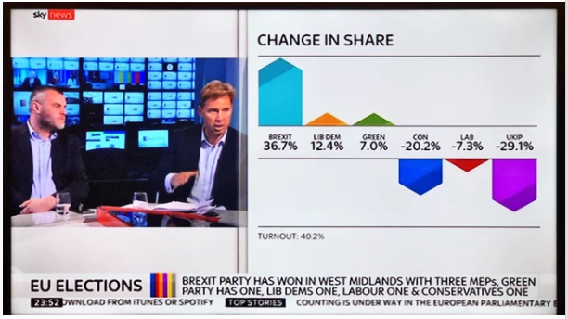

Briefly describe the context for the visual by addressing the following questions:

1. What is the source of the visual? (e.g., URL or bibliographic citation)
2. Who is the intended audience (i.e., decoders)? How do you know this?
3. It is from reddit of a nws channel with URL <https://www.reddit.com/r/dataisugly/comments/btegk8/horrible_bar_chart_scaling_from_sky_news_in_its/>  
   2. The bar chart I used is an image that appeared on a local news channel, so the intended audience would be the general public
4. Identify the specific component(s) of the visual that is/are misleading
5. For each part(s) of the visualization that is/are misleading, identify the mechanism that is used: hiding relevant data to highlight what benefits us; displaying too much data to obscure reality; using graphic forms in inappropriate ways (distorting the data)
6. Explain how the mechanisms are used to mislead

1.The Figure has no y-axis, the space  does not indicate any particular value, and bar height appears random and not in any correlation with stated values atop the bar.   
2. This graph either hides relevant data, or displays too much, i.e.., it should either use value labels and forego the y-axis and grid, or it should use the latter instead but remove values labels and properly label the axis instead. In addition, bar heights are an example ‘using graphic forms in inappropriate ways’, because they seem to distort the data, and they are for that reason simply not informative to the viewer. It is impossible to tell which values are represented based on the bars, which should be the purpose of a bar chart.   
3. The first thing to attract viewers’ attention in this graph is bar height. Based on this, it seems that the category “Green” is the mode(less when compared to LIB DEM), while in reality this answer was given least. Instead, “LIB DEM” is the actual but both are represented as the same. So, this chart communicates the polar opposite of what the reality is.